Quiz #3 Study Guide
Note:
This quiz is based on “Rice” by Jhumpa Lahiri on pages 172-174 in Patterns for College Writing.
All page numbers in the study guide are taken from Patterns for College Writing.
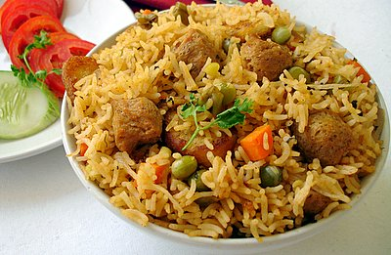
General Items:
- Bring a sheet of loose-leaf paper (the kind without the ripped edges) and a pen with black or blue ink.
- You may use the textbook to complete this quiz. The instructor will give copies of the quiz only to those students who have a textbook, an electronic copy of the textbook, or a photocopy of the assigned essay. Students cannot borrow another student’s textbook or photocopy after that student has completed the quiz.
- Even though students may use their textbooks during the quiz, they must prepare for it before the beginning of the next class. Otherwise, they may discover that they cannot answer all of the quiz items in the allotted time.
- The quiz has three items (two multiple choice and one brief response in the form of at least one complete sentence).

Points to Guide Studying:
- Read the essay “Rice” on pages 172-174. In fact, read it more than once, and annotate it based on the contents of the study guide. For example, underline topic sentences and identify sections relying on objective as opposed to subjective descriptions.
- Read pages 151-161, and become familiar with objective and subjective descriptions, objective and subjective language, and dominant impression, which is discussed in “Developing a Thesis Statement” on pages 157-158.
- Be prepared to identify the topic sentence of one body paragraph. If necessary, review pages 55-56.
Additional Information:
- When individuals provide readers with objectively reported information, they present facts that readers can verify. For example, if a person states that the desk in the Oval Office of the White House used by most presidents after 1880 consists of timbers of the H.M.S. Resolute (a British navy vessel), then he is presenting readers with a fact that they can prove by accessing the official White House website and reading about the furnishings in the Oval Office.
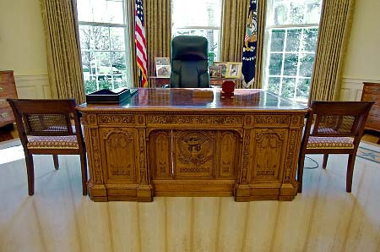
- On the other hand, when individuals provide readers with subjectively reported information, they present opinions that readers cannot verify. For instance, if a person states that the desk in the Oval Office looks “unappealing,” then she is presenting readers with her opinion, and they cannot substantiate it by reading material posted on the official White House website.

- According to the editors of the textbook, dominant impression involves “the mood or quality emphasized in [a] piece of writing” (157). When describing an abandoned house, a writer may focus on such haunted features as barren trees, cobwebs, and eerie sounds, because they relate to its haunted appearance (the dominant impression). He would not describe the type of mortar used during the construction of the house because this information is not related to the dominant impression.
